Customer.io + ClickSend SMS Integration

Direct Approach (No Middleware)

Goal
Send SMS campaigns from Customer.io through ClickSend using 4 phone numbers, each sending up to 10,000 SMS/day, for 40,000 SMS/day total using direct API calls.

How it works
Customer.io's Webhook action can call ClickSend's API directly. ClickSend's inbound webhook can call Customer.io's API directly.
Sending a message:
Customer.io campaign → Webhook action → ClickSend Send SMS API → message delivered.
Handling a reply (e.g. STOP):
Recipient replies → ClickSend inbound webhook → Customer.io Track API → customer profile updated.

Sending SMS from Customer.io
- Use Customer.io's Webhook action in the campaign or broadcast.
- Build the message body using Liquid so it includes the customer's phone number, the message text, and which of the 4 numbers to send from.

Number pool and rotation (static assignment)
Since there's no middleware to track live send counts, numbers are assigned to customers ahead of time instead of rotated in real time:
- Split SMS audience into 4 even segments in Customer.io (for example, based on a modulo of customer ID).
- Assign one ClickSend number to each segment.
- Size each segment so it stays under 10,000 sends/day.

Unsubscribe handling
- same STOP/UNSUBSCRIBE keyword auto-reply on all 4 ClickSend numbers.
- all 4 numbers' inbound webhook at Customer.io's Track API, so a STOP on any number sets one shared attribute on that customer's profile (Subscription center now).

Call forwarding
Call forwarding is a Click Send account feature:
- Contact ClickSend support and request call forwarding for each of the 4 numbers, giving them your main business number as the destination.

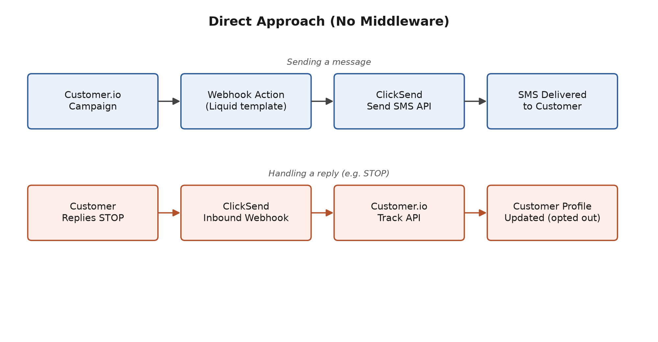

Middleware Approach

Goal
Send SMS campaigns from Customer.io through ClickSend using 4 phone numbers, each sending up to 10,000 SMS/day, for 40,000 SMS/day total, using a middleware service to manage rotation and unsubscribes.

How it works
Customer.io's Webhook action calls a middleware service. The middleware calls ClickSend's API. ClickSend's inbound webhook also calls the middleware, which then updates Customer.io.
Sending a message:
Customer.io campaign → Webhook action → Middleware (picks number, checks daily cap) → ClickSend Send SMS API → message delivered.
Handling a reply (e.g. STOP):
Recipient replies → ClickSend inbound webhook → Middleware (looks up contact, sets suppression) → Customer.io Track API → customer profile updated.

Sending SMS from Customer.io
- Use Customer.io's Webhook action in the campaign or broadcast, pointed at the middleware instead of ClickSend directly.
- Middleware builds the ClickSend request, choosing the sending number and including the customer's phone number and message text.

Number pool and rotation (live assignment)
Since the middleware tracks real send counts, numbers are rotated live instead of pre-assigned:
- Middleware keeps a running count of sends per number per day.
- Each new message is assigned to whichever number is under its 10,000/day cap.
- If a number reaches its cap, sends automatically move to the next available number.

Unsubscribe handling
- same STOP/UNSUBSCRIBE keyword auto-reply on all 4 ClickSend numbers.
- all 4 numbers' inbound webhook goes to the middleware, which looks up the contact and updates Customer.io's Track API, so a STOP on any number sets one shared attribute on that customer's profile (Subscription center) and blocks sends from all 4 numbers going forward.

Call forwarding
Call forwarding is a Click Send account feature, the same either way:
- Contact ClickSend support and request call forwarding for each of the 4 numbers, giving them your main business number as the destination.

